1. **git init**
   * Initializes a new Git repository in the current directory.

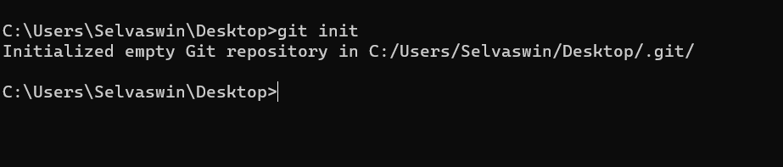

1. **git clone <repository_url>**
   * Creates a copy of a remote repository on your local machine.

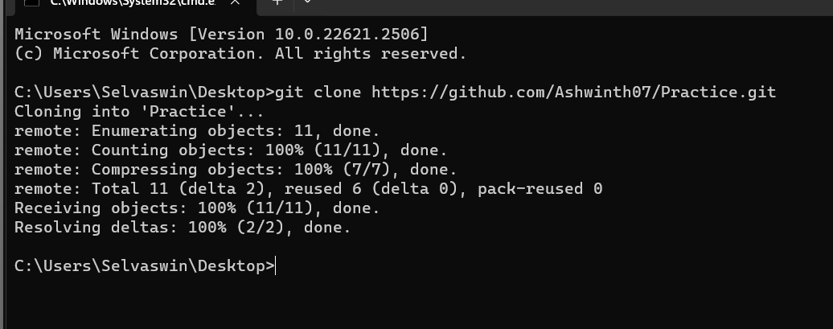

1. **git add <file(s)>**
   * Adds file(s) to the staging area for the next commit.

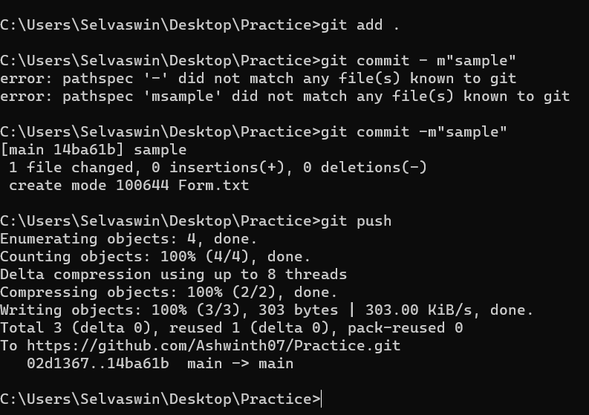

1. **git commit -m "commit message"**
   * Records changes in the repository with a message describing the changes.



1. **git status**
   * Shows the current state of the repository, including changes and staged files.

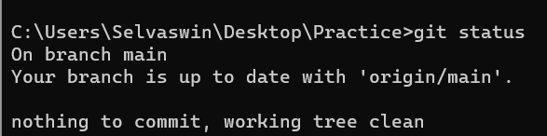

1. **git pull**
   * Fetches and integrates changes from a remote repository to your local repository.

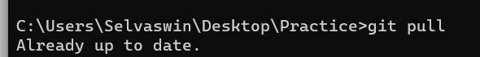

1. **git push**
   * Uploads local repository changes to a remote repository.



1. **git branch**
   * Lists all branches in the repository.

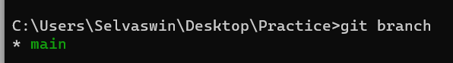

1. **git branch <branch_name>**
   * Creates a new branch.

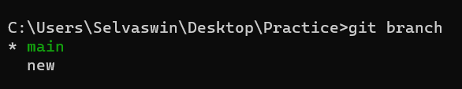

1. **git checkout <branch_name>**
   * Switches to a different branch.

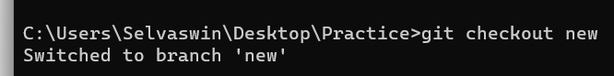

1. **git merge <branch_name>**
   * Combines changes from the specified branch into the current branch.

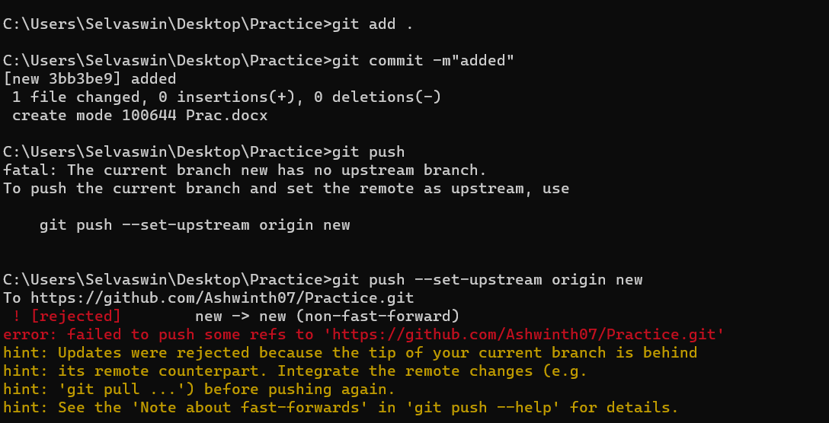

1. **git remote -v**
   * Lists all remote repositories associated with your local repository.

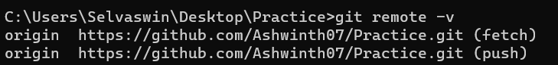

1. **git remote add <name> <url>**
   * Adds a new remote repository.

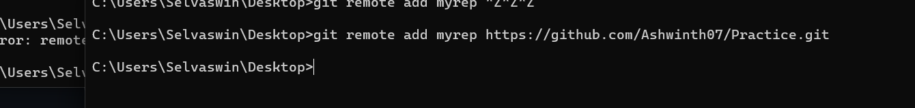

1. **git remote remove <name>**
   * Removes an existing remote repository.

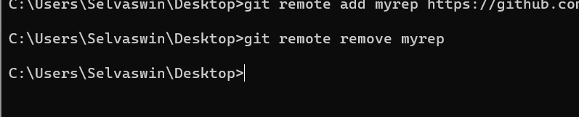

1. **git log**
   * Displays a history of commits.

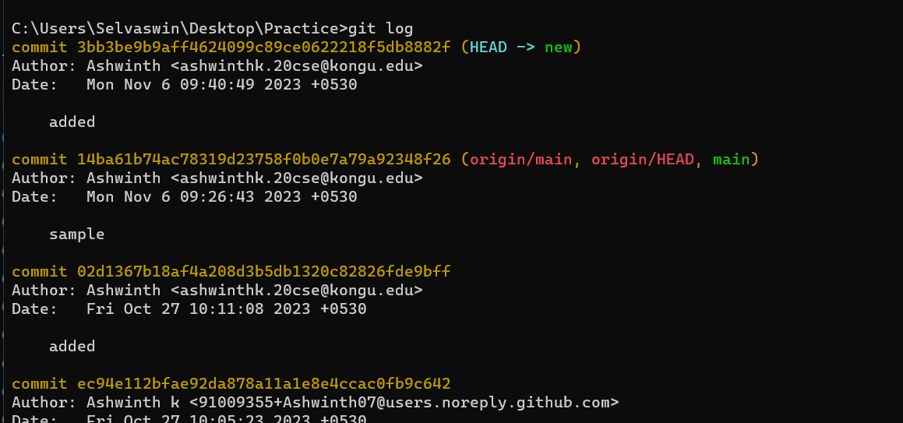

1. **git diff**
   * Shows the changes between commits, branches, etc.

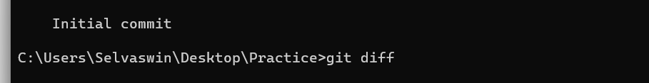

1. **git reset <file(s)>**
   * Unstages file(s) from the current commit.
2. **git revert <commit_id>**
   * Undoes a specific commit by creating a new commit with the opposite changes.

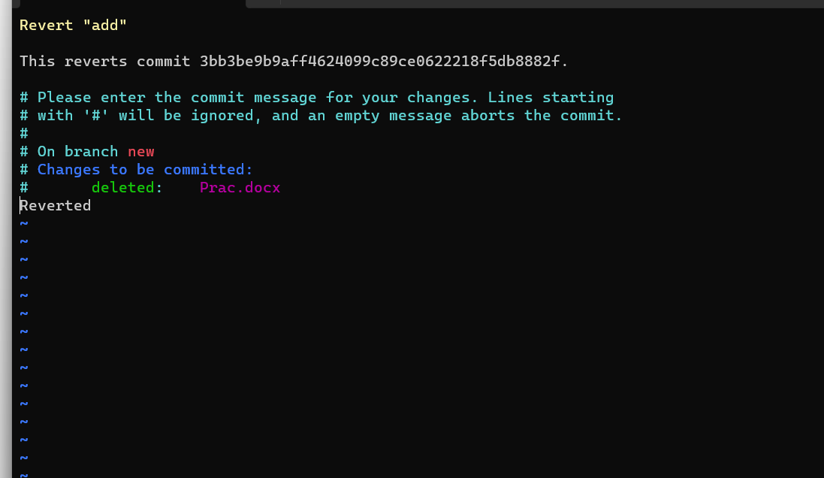

1. **git push origin --delete <branch_name>**
   * Deletes a remote branch.

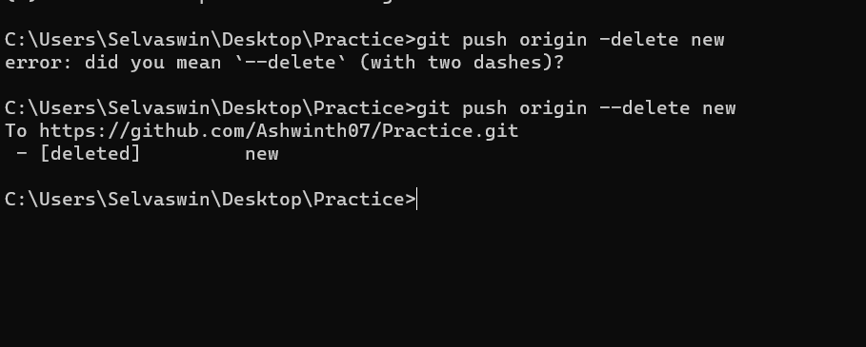

1. **git config --global user.name "Your Name"**
   * Sets your Git username.
2. **git config --global user.email "**[you@example.com](mailto:you@example.com)**"**
   * Sets your Git email.